**DESIGN STUDIO USER GUIDE**

Table of Contents

DESIGN STUDIO INSTALLATION 2

CREATING TEMPLATE PACKAGER PROJECT 4

IMPORTING GIT REPOSITORY 9

COMPILING ROUTUNES IN T24 SERVER 14

DATA RECORDS CREATION AND MODIFICATION 18

Pre-requisites: 18

Import T24 Applications: 18

Importing T24 Local Fields Definition(LT): 21

Importing T24 Localref Applications(LRT): 23

Uncheck XML for Local Fields 25

Importing and modifying the existing Screens Records: - 27

Importing Screen Records: 27

Creating Screen Records: 31

Importing and modifying the existing Enquiry Records: - 34

Importing Enquiry Records: 34

Creating Enquiry Records: 39

Extract T24 Data File 43

# DESIGN STUDIO INSTALLATION

**Step1.** Before installing the DESIGN STUDIO in your local desktop or VM, you need to ensure first, that DS

(Design Studio) PRODUCT is installed in your T24 environment.

Please refer the below attached document on DS PRODUCT INSTALLTION USER GUIDE.

**Step2.** Copy and extract the latest version of Design Studio package to a dedicated folder.

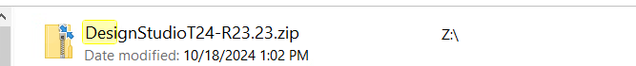

**Step 3.** Copy the t24-binaries ZIP file as per Design Studio version received from Temenos Distribution team to the folder where Design Studio file is extracted.



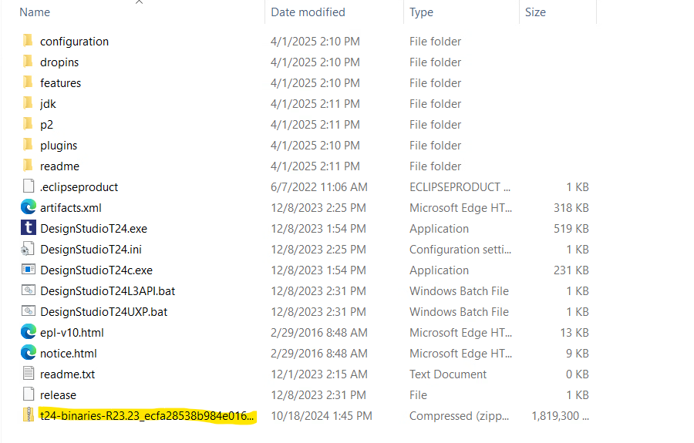

**Step 4.** Execute DesignStudioT24.exe to launch Design Studio.

Click on Launch.

Design Studio should automatically detect the t24-binaries ZIP and prompt you to install it. Click "Yes".

If Design Studio is unable to process the t24binaries zip file, then extract the t24binaries zip manually into the Design Studio directory and delete the zip file.

Restart Design Studio.

# CREATING TEMPLATE PACKAGER PROJECT

**Step 1.** When Design Studio is launched for the first time, it will by default opened in **Design Studio perspective**.

You can change the perspective in Design Studio from **Windows** option.

Windows > Perspective > Open Perspective > Other

Once you click on Other, you will see the list of available perspectives within Design Studio.

To work with TAFC in Design Studio, choose jBC (TAF/C) perspective an open.

**Step 2.** To Create a packager project, you can directly click on “**Create a project**” or you can go to “**File > New > Project**”.

Select **Design Studio Template** Projects and click on **Next**.

You will be redirected to following Window.

Click on Drop Down in Choose a Template Field and select **t24-packager-tafc**.

Once you select the template, you will be redirected to the page where you are supposed to provide relevant values to the parameters below.

**Mandatory Parameters:** Values of these parameters must be provided.

|  |  |
| --- | --- |
| **Field** | **Description** |
| **Project Name** | Name of the project. |
| **Release** | Release version of the project. |
| **Version** | Specific version of the project. |
| **T24 Home** | bnk.run path for T24 home directory. |
| **T24 Infra** | bnk.run path for T24 infrastructure. |
| **InsertDir** | Path to t24lib directory. |
| **Host** | Target server hostname. |
| **Agent Port** | TAFC agent port number. |
| **T24 Username** | Username for T24 login. |
| **T24 Password** | Password for T24 login. |
| **Username** | Username for the T24 server. |
| **Password** | Password for the T24 server. |

**Optional Parameters:** Values of these parameters may or may not be provided.

Component-name (your-comp)

**Note:** Unless you provide all the details, Finish button won’t get enabled.

Once you click on Finish button, Design Studio will create a t24-packager-tafc project within few minutes.

**Note:** When we create a packager project in Design Studio, the server.properties automatically created with default name (t24-server). We can also rename the server.properties file as per our convenience. Ex- dev-server, sit-server, uat-server, etc.

Initially, when you open the server.properties file, you will face below error.

This happens because the file is yet to be filled with few values and saved. The moment you save it and create the connection; Design Studio will save the details in its workspace.

**Note:** Remember every time you made changes in the file, you need to save it.

Post providing the highlighted details. Click on Get.

Now save the file and close it to prevent it from getting modified.

# IMPORTING GIT REPOSITORY

To import the git repository in your workspace or location of your choice. Kindly follow the instructions given below.

**Step 1.** Make sure you are working on TAFC perspective.

Right Click on Workspace area and click on import.

Now click on **Git drop down** and select **“Projects from Git (with smart import)”** and click on next.

Now, select **Clone URI** and click on Next.

Open Git Repository project.

Click on Clone option and copy the **https url** under **Clone with HTTPS**.

Paste it in below window,

Provide UserId and Token key (in Password) and click on **Next**. You must have a userid and tokenkey in order to import your git repository to Design Studio.

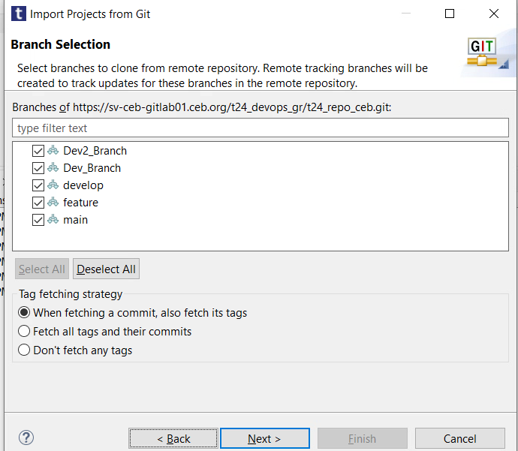

You will see the relevant branches in you Git Repository. Click on Next.

It will ask you to provide the destination path to Configure the local storage location for your repository.

Note: To work properly hand in hand with both Design Studio Project and Git Repository, it is advised to give your local git repository location inside the Design Studio Workspace where you are managing your project.

Now, click on Finish.

The Above Setup is in TAFC perspective. This TAFC perspective is useful to create and compile your routine records on server either on your tafc-packager project or under you GIT repository folders.

To Push your changes in GIT, you need to open the GIT perspective in design Studio as shown,

Windows > Perspective > Open Perspective > Other > Git 🡪 open

# COMPILING ROUTUNES IN T24 SERVER

To Compile Pre-existing routines or newly created routines on T24 Server, make sure your server in Design Studio is running in Active mode or Active Debug Mode as per your convenience.

Active Debug Mode recommended to view the logs in detail.

In your project, go to data-code > src > Source > Private > fr0010001(default your-comp).

To create new routine, Right click on fr0010001(default your-comp) > New > T24 routine

Give name of your routine and click on Finish.

Open the Routine and write code and save it.

Note: Before compiling the routine, it must be in opened.

Now right click on routine and go to T24 jBC (TAF/C) > Compile in Server

It will ask you for below details,

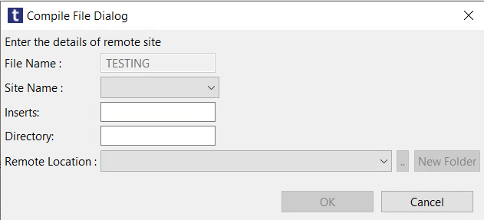

**Site Name:** From the dropdown, select the server configured for the project.

**Inserts:** t24lib (under /t24/dev/bnk.run)

**Directory:** Specify the target folder where you want your routine to be saved after compilation.

**Remote Location:** This is automatically set to /t24/dev/bnk.run once you select the Site Name. However, you can modify the Remote Location as needed to match the target folder where your compiled routines should be saved.

Click OK. Post Successful compilation, you will see the Design Studio console logs.

You can also verify the same from backend.

You can edit the previously created routines and compile them on t24 server.

# DATA RECORDS CREATION AND MODIFICATION

## Pre-requisites:

1. Import T24 Applications
2. Importing T24 Local Fields Definition(LT)
3. Importing T24 Localref Applications(LRT)
4. Uncheck XML for Local Fields

### Import T24 Applications:

**Note:** It is strongly advised to un-select the menu entry **Project > Generate Automatically** from your workspace. With this selection, imported models are automatically deployed back to the T24 server.

**Procedure**

1. Create Applications Folder under models.

New > Folder

Provide Folder name as Applications and click on Finish.

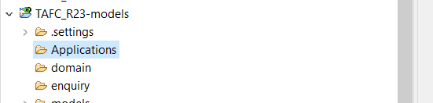

1. Right Click on Applications Folder > Import > Design Studio > Import T24 Applications A screenshot of a computer application

   AI-generated content may be incorrect.

Click Next.

1. Select the required T24 server if there are more than one server otherwise connection to T24 server happens automatically and click Next.

1. Select the Applications you want to import. For a global selection, click on the select all button. You can filter the selection by Application Name.

1. Click on Next and select the DS project model where you want the Applications to be imported. There are 3 options for project visibility- All projects, Only model projects(default) and Only data projects.

By default, Design Studio will choose Only models projects. Keep as it is and click on Finish.

**Result**

The selected applications are imported in your selected folder based on the product to which the application belongs. The applications are automatically organized in domain models by the import process.

### Importing T24 Local Fields Definition(LT):

**Note:**It is strongly advised to un-select the menu entry Project > Generate Automatically from your workspace. With this selection, imported models are automatically deployed back to the T24 server.

**Procedure**

* 1. **Select File > Import > Design Studio - Import T24 Local Fields Definition (LT)**or in the Servers view pane, right-click and choose Import > Import T24 Local Fields Definition (LT) or use shortcut CTRL+I to open import wizard.

* 1. Select the required T24 server if there are more than one server otherwise connection to T24 server happens automatically and click Next.

* 1. Select the Local Fields Definition(s) you want to import. For a global selection, click on the select all button. You can filter the selection by Local Field ID.

* 1. Click on Next and select the DS project model where you want the local fields to be imported. There are 3 options for project visibility- All projects, Only model projects(default) and Only data projects.

Click Finish button.

**Result**

The selected fields are imported in Domain/localFieldDefinition location. The import of local field definition creates two domain models.

* LocalFieldsEnumeration: List of vetting tables transformed into domain enumeration during the introspection.
* LocalFieldsDefinition: domain model holding the class LocalFields where each attribute is a local field.
* All new T24 char types found in the imported local fields are added as business types. It may then update the business types: domain\businessTypes\BusinessTypes.domain

Each import overrides completely the local fields domain models, even if only one local field definition is imported.

### Importing T24 Localref Applications(LRT):

**Note:**It is strongly advised to un-select the menu entry Project > Generate Automatically from your workspace. With this selection, imported models are automatically deployed back to the T24 server.

**Procedure**

1. Select **File > Import > Design Studio - Import T24 Localref Applications (LRT)** or in the Servers view pane, right-click and choose Import > Import T24 Localref Applications (LRT) or use shortcut CTRL+I to open import wizard.

**Result:** T24 LocalRef Applications (LRT) Import wizard is open.

1. Select the required T24 server if there are more than one server otherwise connection to T24 server happens automatically and click Next.

**Result:** DS connects to the T24 server and retrieves all existing extension of applications with local ref.

1. Select the Local ref application(s) you want to import. For a global selection, click on the Select All button. You can filter the selection by local ref application name.

**Result**

1. Click on Next and select the DS project model where you want the Localref Applications to be imported. There are 3 options for project visibility- All projects, Only model projects(default) and Only data projects.

Click Finish button.

**Result**

The selected fields are imported in Domain/localRefApplication location. The import of local ref application creates one domain model per extended application named like: X_[ApplicationName] . Each multi-value group becomes a separate class in the same domain file. This class is referenced by X_[ApplicationName] one with multiplicity many. Each import completely overrides existing domain model.

### Uncheck XML for Local Fields

Go to models project > right click and select Properties > expand Design Studio > click Code Generation > expand All Categories > Uncheck XML for Local Fields (LT/RTL)

Click Apply and Close.

## Importing and modifying the existing Screens Records: -

### Importing Screen Records:

1. **Select File > Import > Design Studio - Import T24 Screens** or in the Servers view pane, right-click and choose Import > Import T24 Screens or use shortcut CTRL+I to open up the Import wizard.

1. Select the required T24 server if there are more than one server otherwise connection to T24 server happens automatically and click **Next**.

1. Select the screen(s) you want to import. For a global selection, click on the Select All button. You can filter the selection by: application, screen short name, module and component. This page consists of Folder Structure where there are options to import the models ProductWise, ComponentWise or Flat import.

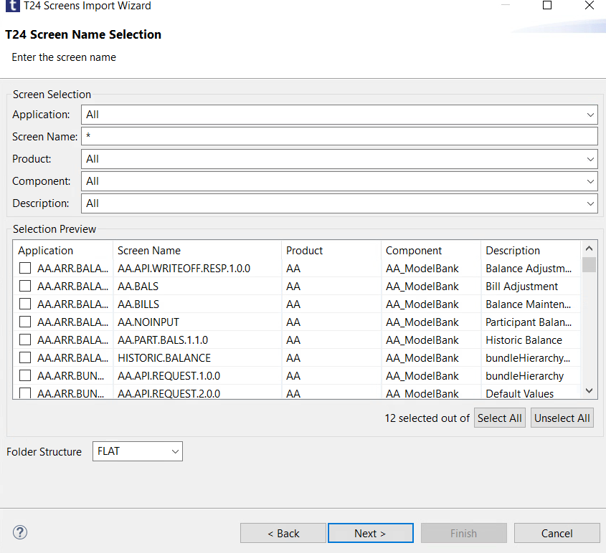

1. Click on Next and select the location where you want the screens to be imported. There are 3 options for project visibility- All projects, Only model projects(default) and Only data projects.

1. Click **Finish** button.

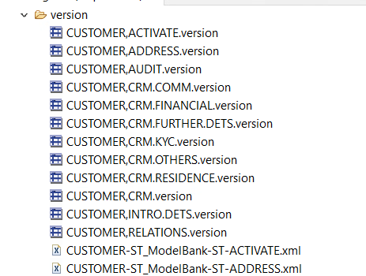

1. Now we can modify one of the imported screens by double clicking on it and do the changes as per requirement and save it.

EX: - Changing the description of Screen CUSTOMER,ACTIVATE.version.

1. Till now the changes are reflecting in our local Workspace of Design Studio. Now to reflect this change at server level. Make sure T24 server is Active in Design Studio.
2. To make changes at server level for Modified screen Record. Right Click on T24 Screen on which you performed the changes, go to **Design Studio > Generate Code**.

1. Once the code is generated successfully, you will see the logs as below.

1. The Generate Code is nothing is just an xml file generated under **models-gen > src > xml-t24i > version.**

1. You can verify the change on Server either through T24 Browser or T24 Classic.

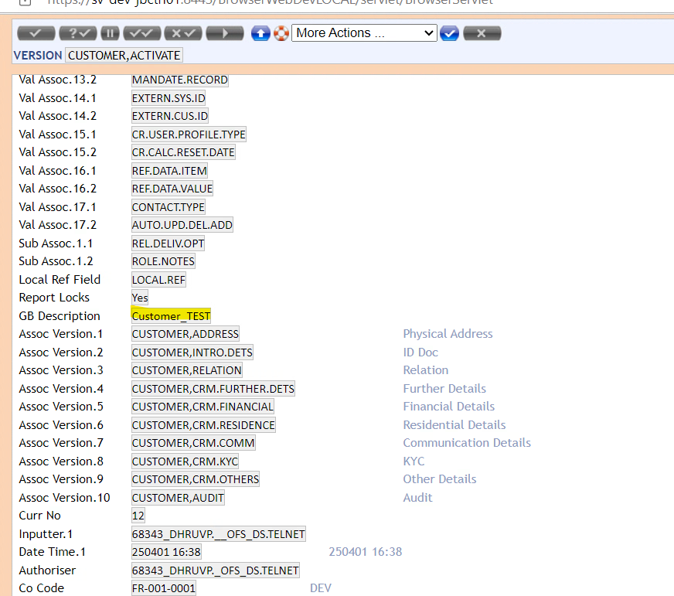

### Creating Screen Records:

1. To Create a new Screen Record, please follow below steps:

Under models project right Click on Version > New > Other > Design Studio > T24 > New Screen

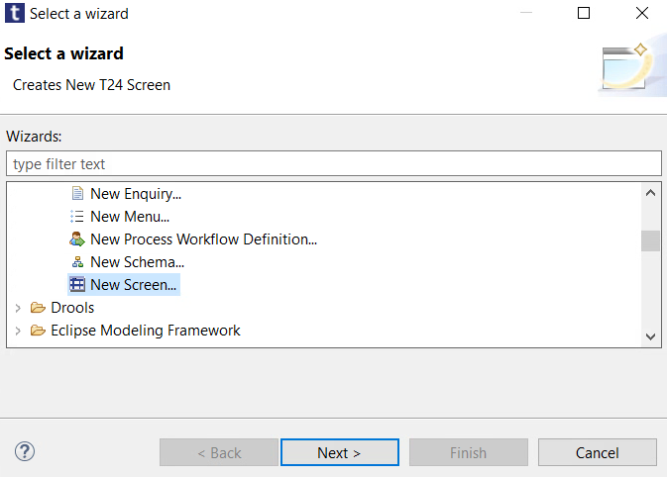

Click Next.

1. Browse the Application for which you want to create a new screen.

Click Ok and provide the Screen Name.

Click Finish. A new Screen will get created under version folder in models’ project.

1. Do the changes in your newly created screen record as per requirement and save it.
2. Once it is saved, Generate the Code. Post Successful Generation, New Screen will be available on T24 Server.

**Note:** In Above screenshot you can see the Code generated successfully for the modified Screen record CUSTOMER,ACTIVATE and newly created screen record CUSTOMER,CUSTEST.

## Importing and modifying the existing Enquiry Records: -

### Importing Enquiry Records:

**Note:** It is strongly advised to un-select the menu entry Project > Generate Automatically from your workspace. With this selection, imported models are automatically deployed back to the T24 server.

**Procedure**

1. Select File > Import > Design Studio - Import T24 Enquiries or in the Servers view pane, right-click and choose Import > Import T24 Enquiries or use shortcut CTRL+I to open up the Import wizard.

1. Select the required T24 server if there are more than one server otherwise connection to T24 server happens automatically and click Next.

1. Select the enquiry(ies) you want to import. For a global selection, click on the Select All button. You can filter the selection by Application, module and component name.This page consists of Folder Structure where there are options to import records/ models ProductWise, ComponentWise or Flat import.

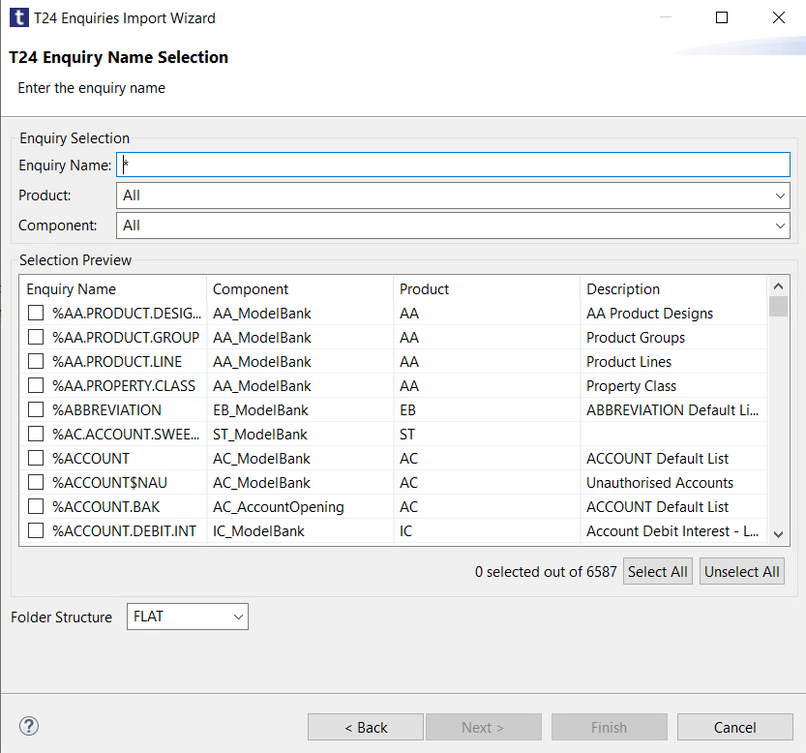

1. Click on Next and select the location where you want the Enquiries to be imported. There are 3 options for project visibility- All projects, Only model projects(default) and Only data projects.

1. Click Finish button.

The selected files are imported in the chosen location.

1. Now we can modify one of the imported Enquiry by double clicking on it and do the changes as per requirement and save it.

Ex: - Changing HEADER in CUSTOMER.enquiry.

Before,

After,

1. Till now the changes are reflecting in our local Workspace of Design Studio. Now to reflect this change at server level. Make sure T24 server is Active in Design Studio.
2. To make changes at server level for Modified Enquiry Record. Right Click on Enquiry on which you performed the changes, go to **Design Studio > Generate Code**.

1. Once the code is generated successfully, you will see the logs as below.

1. The Generate Code is nothing is just an xml file generated under **models-gen > src > xml-t24i > enquiry.**

1. You can verify the change on Server either through T24 Browser or T24 Classic.

### Creating Enquiry Records:

1. To Create a new Screen Record, please follow below steps:

Under models project right Click on Enquiry > New > Other > Design Studio > T24 > New Screen.

OR

File > New

Click Next.

1. Browse the Application for which you want to create a new enquiry.

1. Click Ok and provide the Enquiry Name and Header.

1. Click on Next and Select the Fields to be added in your Enquiry.

1. Click on Finish and new Enquiry will get created under version folder in models’ project.

1. Do the changes in your newly created screen record as per requirement and save it.
2. Once it is saved, Generate the Code. Post Successful Generation, New Screen will be available on T24 Server.

**Note:** In Above screenshot you can see the Code generated successfully for the modified Enquiry record CUSTOMER and newly created enquiry record CUSTENQ.

## Extract T24 Data File

A data file holds a T24 data record in text form. T24 jBC (TAF/C) perspective identifies any file with a “.d” extension as a data file. Follow the below steps to create a data file.

**Procedure**

1. A new data file can be created using a wizard from data-code > src > Data > Model > fr001001(your-comp).

1. This new wizard helps in creating a new data record by collecting T24 file name and record key separately and applying conversion if required.

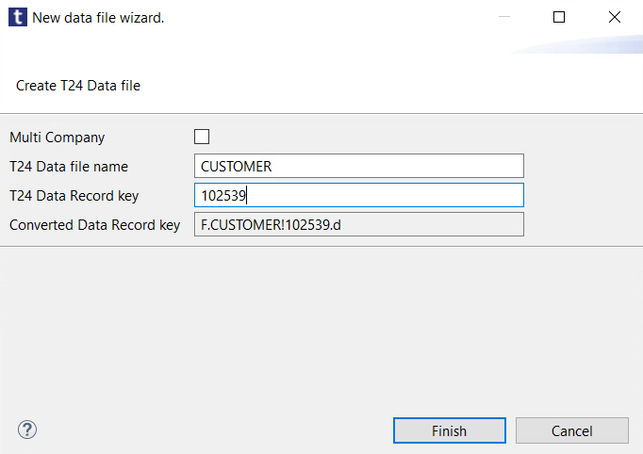

1. Click on Finish and a new data record will be created.

1. The Data record will open by default in T24 Editor, where you can Extract the data record from a file to Design Studio and from where you can deploy it back to T24 Server.

**To Extract - Get from T24**

**To Deploy – Send to T24**

1. To edit the data record in Design Studio, use either Generic Editor or any other Text Editor.

Note: T24 Text Editor can only be used to Extract the Data Record from a File to Design Studio and Deploying it back to T24 Server.

1. Once you make the changes in you Data record using Generic Text Editor. Open the record in T24 Data Editor and click on **Send to T24.**

Now your modified record is deployed in to the T24 server, but in INAU (Input Unauthorised State). To Authorise the same login to Browser and Classic to Authorise the record.

**Note:** A T24 data record is conventionally stored in source control systems with its T24 file name (Eg., F.FILE.CONTROL) and T24 record key (Eg., AM.MY.NEW.FILE). Due to some unsupported characters in the existing data record keys, there would be a conversion applied automatically during transit between plug-in and T24 remote environment.